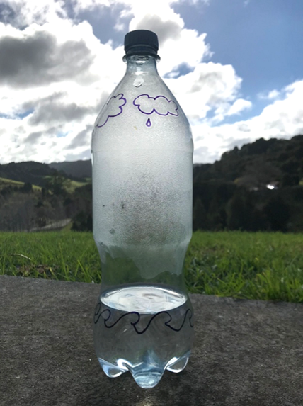
Investigating the water cycle

This sealed plastic bottle containing warm water was placed in a sunny spot for over 4 hours. The bottle acts a bit like our atmosphere and shows how water moves around, as it does in our Earth system. You can see the processes of evaporation and precipitation occurring inside the bottle. Liquid water heats up and evaporates into water vapour. The water vapour then rises, coming into contact with the outside of the bottle and cools, condensing into water droplets. These droplets then precipitate, falling back down into the bottle, a bit like rain does from clouds. And on it goes, around in a water cycle!

Your challenge: Design a model that allows you to investigate and observe at least two processes in the water cycle.

Criteria for your model:
- A closed, sealed system model where water can physically change from different states
- Show at least two processes in the water cycle (evaporation, condensation, precipitation)
- Be placed in a warm or cool position to drive changes in water’s states
Materials needed
Plan – draw a picture of or describe your model design
Describe two processes from the water cycle and explain how you have observed them
Other observations

Results and conclusions

What worked well with your model?

What challenges did you have? How did you overcome them?

